

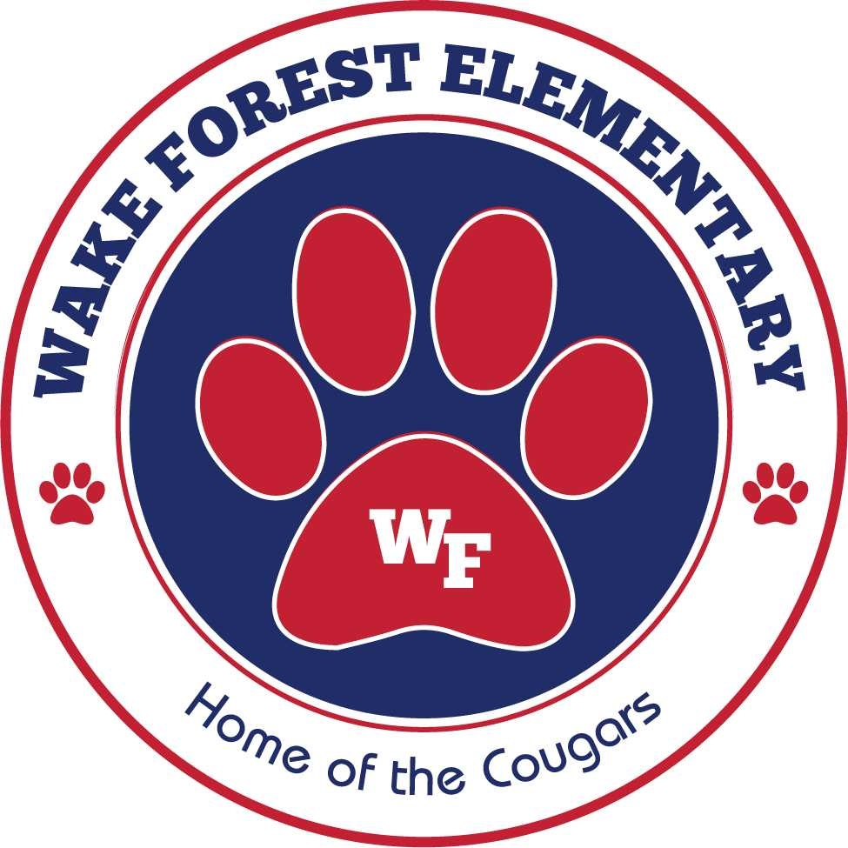

**WFE First Grade**

**Week of December 16, 2019**



### Important Dates

#### Don’t Forget

December 20 – Regular School Day, Weather Make-up

December 23 – January 3 Holiday Break No School

January 20 – No School Holiday

Please join us for our Holiday’s Around the World presentation December 20th in the auditorium at 10:30! Have students wear festive colors.

Reading Calendar due December 17 for pizza coupons.

### Homework

#### Spelling test on Friday over list A, tricky words and sentences.

##### -Read for 25 minutes every night.

-Talk about what you read with a grown up. Describe the characters, setting and plot. Use words like first, next, then and last.

**Monday** – Read for 25 min and record on the “Gift of Reading” log.

**Tuesday** - Read for 25 min and record on the “Gift of Reading” log.

**Wednesday**- Read for 25 min and record on the “Gift of Reading” log.

**Thursday** - Read for 25 min and record on the “Gift of Reading” log.

This week’s unit 15 letterland is review in the classroom only and will not be a test grade.

### Contact us anytime!!

#### Reenada Perez

#### MrsRPerez.weebly.com

##### [rperez@wcpss.net](mailto:rperez@wcpss.net)

#### Renee Dixon

rdixon@wcpss.net

#### Mary Jones

**www.cougarsfirst.weebly.com**

Mjones5@wcpss.net

For access to spelling words or study materials check your teacher’s website.

