



**WFE First Grade**

**Week of January 13, 2020**

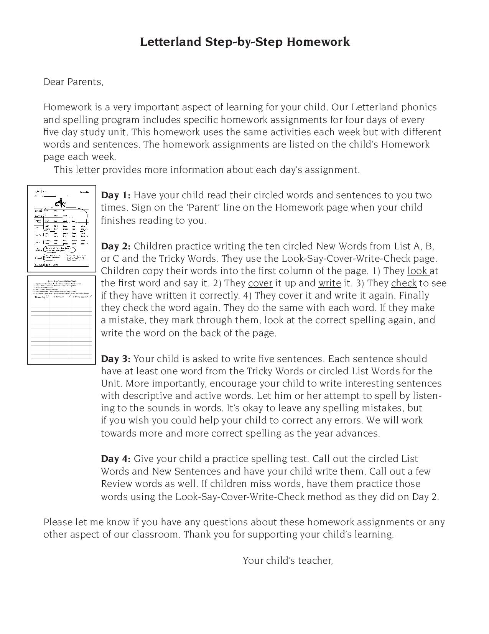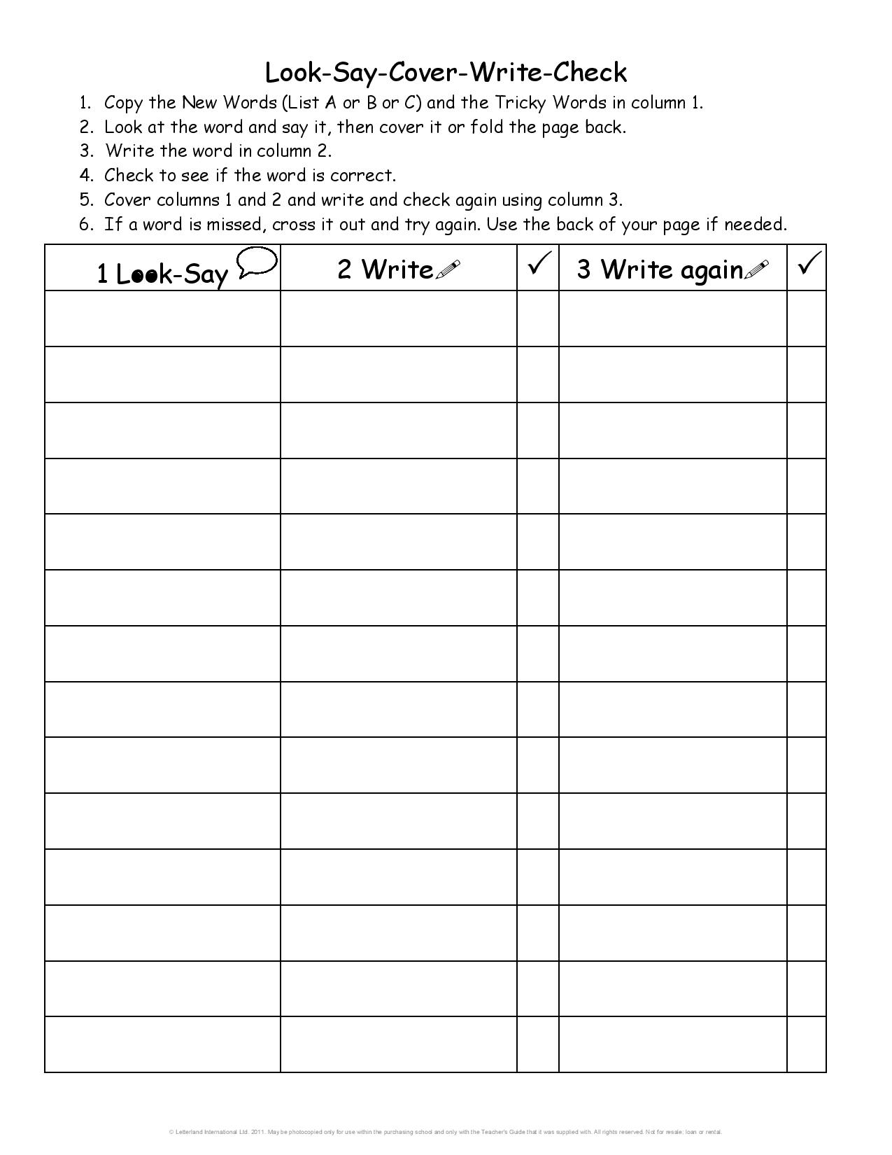

### Important Dates

#### Don’t Forget

January 20 – No School Holiday

January 29 – No School Teacher Work Day

February 17 & 18 – No School

March 9 – No School Teacher Work Day

April 6-13 – No School Spring Break

### Homework

#### Spelling test on Friday over list A, tricky words and sentences.

##### -Read for 10-20 minutes every night.

-Complete the Math worksheet and turn in by Friday every week.

**Monday** – Read the list A words, tricky words and sentences out loud to a grown-up.

**Tuesday** - Practice writing the words without looking at them.

**Wednesday**- Choose 5 words from your list A or Tricky words to write in a sentence.

**Thursday** -Have a grown up give you a practice spelling test with you List A, Trick words, and sentences.

There will be a spelling test every Friday.

### Contact us anytime!!

#### Reenada Perez

#### MrsRPerez.weebly.com

##### [rperez@wcpss.net](mailto:rperez@wcpss.net)

#### Renee Dixon

rdixon@wcpss.net

#### Mary Jones

**www.cougarsfirst.weebly.com**

Mjones5@wcpss.net

For access to spelling words or study materials check your teacher’s website.

