

WFE First Grade

Week of September 9, 2019

Homework

Spelling test on Friday over list A, tricky words and sentences.

-Read for 10-20 minutes every night.

-Complete the Math worksheet and turn in by Friday every week.

Monday - Read the list A words, tricky words and sentences out loud to a grown-up.

Tuesday - Practice writing the words without looking at them.

Wednesday- Choose 5 words from your list A or Tricky words to write in a sentence.

Thursday -Have a grown up give you a practice spelling test with you List A, Trick words, and sentences.

There will be a spelling test every Friday.
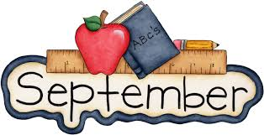

Important Dates

Don’t Forget

September 30 - No School Teacher Workday

October 9 – No School Teacher Workday

October 31 – No School Teacher Workday

November 1 – Regular School Day, Weather Make-up

December 20 – Regular School Day, Weather Make-up

Contact us anytime!!

Reenada Perez

MrsRPerez.weebly.com

rperez@wcpss.net

Renee Dixon
rdixon@wcpss.net

Mary Jones
www.cougarsfirst.weebly.com
Mjone5@wcpss.net

For access to spelling words or study materials check your teacher’s website.


